Vehicle Scale Proposal
Proposal 070216SG1





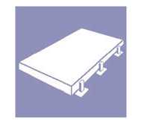


Presented to: Mr. Ravi Ghate Phone: 1-506-789-4302
Avcell Inc. Fax : 1-506-789-4122
175 Mill Rd
Athol Ville, NB
E3N 4S7

Presented by: Simon Gosselin February 16, 2007
Industrial Inside Sales Specialist
Tel : (800) 523-5123
Fax : (614) 430-2577
Email : simon.gosselin@mt.com

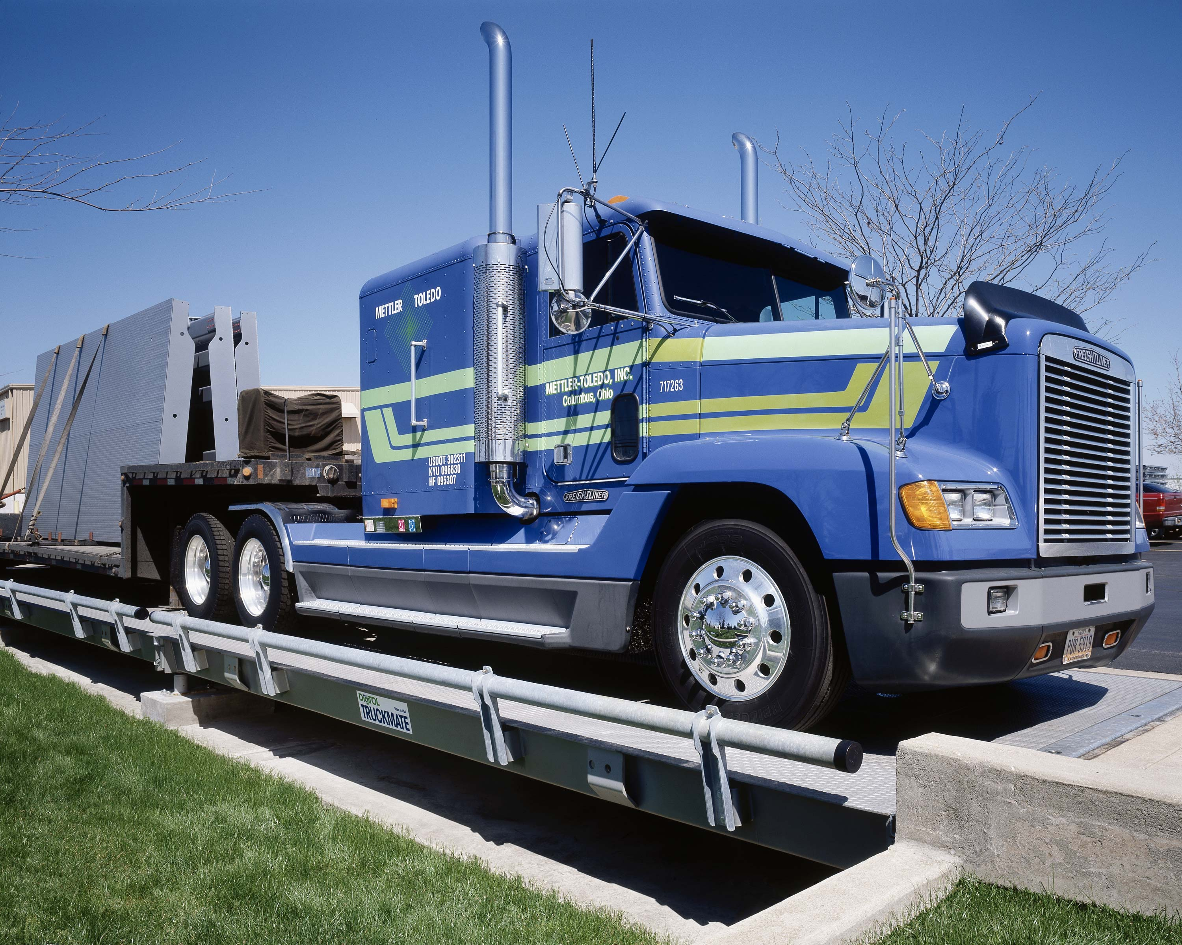

1 : Vehicle Scale and Related Accessories

- Modèle 7461RD9011-1 (ANALOG)
- 90' long x 11' wide
- Orthotropic Steel Deck Design
- 60,000 lb. Concentrated Load Capacity
- 200,000 lb. Scale Capacity
- Minimum increment size, 20 lb.
- NTEP CC : 01-070
- Commercial Duty ( Up to 100 cycles per day, average )
- Premium Finish
- Factory Assembled Modules
- Stainless Steel Jonction Boxes
- Two (2) Manholes, First and end module
- Installation Kit of Parts
- Five-Year Guarantee (see Vehicle Warranty Policies at page 7)
- One Set of Foundation and Layout Prints
- One Set of Service Manuals
- F.O.B. Columbus Ohio
- Home Run Cable # 510620370 (100’)
- T-Grip 11’ # 082453011 (2x)

Load Cells:

- Model 0782, Analog,
- Capacity of 30,000 kg
- Protection Class: IP68
- AISI Type 304 SS Can
- AISI Type 304 SS Counterforce Material
- NTEP CC: 01-004
- Temperature Compensation Range: -10 to +40C
- Safe Operating Temperature Range: -30 to +65C
- Rated Output: 2mV/V

2: Not Include

PRICE DOES NOT INCLUDE: (Provided by Others)

The materials and services described below are required to make your
METTLER TOLEDO scale system operational and are to be furnished by others.
Other materials and services not described in this section in detail may be required depending on installation, site conditions, and interfacing
equipment.
• Scale House and Foundation or concrete pads and any modifications
• Installation of scale onto Foundation
• Weights and Measurements fee.
• Any Required Permits, Building Variances, Zoning Variances, etc.
and any and all Union Labor / Costs (if required).
• Any and all on-site Electrical Contracting / Labor including power
supply requirements to scale site and running of all conduit / pulling
of wires through conduit for all electrical devices (if required). All
electrical power supplied to scale site, (115 VAC, 60 Hz cycle), must
be on an isolated power circuit of computer grade service.
• Crane for offloading and placement onto foundation
• Suitable strain loads of vehicles for sectional and scale capacity test
(minimum two tri-axle gravel trucks fully loaded).
• Options will be charged as extra

3: Option

- METTLER TOLEDO scoreboard model ADI310

The ADI310 scoreboard is a highly visible weight display for use with vehicle scales and other industrial weighing applications. Its light-emitting diodes display up to six characters, plus lb/kg and GR/NT designators. The bright display is easy to read at distances of 150 feet or more, even at night.

- Enclosure : Aluminum alloy with polyester powder coating
- Environmental Protection : IP56 (Type 4)
- Dimensions : 188 mm Height x 762 mm Width x 171 mm Depth
- Weight : 10.4 kg
- Operating temperature: -40C to +55C
- Characters : 6 characters, 4’’ (100 mm) high

Price: ………………………….…….…………………………………………… 1,695.00$

IND310 Truck Scale Terminal # 31L1000000V0A19

Introducing the IND310drive,the premier vehicle weighing terminal from METTLER TOLEDO. This amazing new indicator brings a renewed focus on the key elements of the vehicle weighing process, resulting in ease of use for the operator.
Price: ………………………….…….…………………………………………… 2,295.00$
- MODEL APR310 TICKET PRINTER # 64058701

The Model APR310 is a dependable multi-purpose document printer which will print on multi-copy forms. The APR310 will print data exactly as transmitted by the source device allowing the APR310 to operate with a variety of weight transmission devices.

Standard features include:

- Prints legible 9 x 6 dot matrix characters
- 3.1 lines per second maximum
- Accept multi-copy forms (Original + 2)
- Serial Interface (RS-232 standard), 25 pin
- Utilizes an easily replaceable ribbon cartridge
- Printer cable # 09000309000 included

Price: ………………………….…….…………………………………………… 1,375.00$

- METTLER TOLEDO Riser Base Plate # RP-6

Riser base plate 6” (Ensemble de 12) : …………………………………… 2,200.00$

4: Price summary

80’ x 11’ 7461 TRUCKMATE Scale : 43,275.00 $
T-Grip 08245301 (2X): Include
100’ Home run cable 510620370 Include

5: Price of Options

- METTLER TOLEDO scoreboard model ADI310: ………… 1,695.00$

- IND310 Truck Scale Terminal # 31L1000000V0A19: ……. 2,295.00$

- MODEL APR310 TICKET PRINTER # 64058701: ………… 1,375.00$

- METTLER TOLEDO Riser Base Plate # RP-6: …………… 2,200.00$

Conditions
This quotation is valid for 30 days!

Official terms and conditions per our official quotation form prevailing. Prices are subject to change without notice.

Terms: 25% WITH THE ORDER
75% NET 30 DAYS* FROM DELIVERY DATE.

Taxes: EXTRA FEDERAL & PROVINCIAL

Freight: EXTRA FOB Columbus Ohio

Installation: EXTRA: 4,500.00$

Calibration: INCLUDE WITH INSTALLATION

Inspection: EXTRA
W & M
Canada

Delivery: To be determined

Warranty: Five-Year Guarantee (see Vehicle Warranty Policies at page 7)

We thank you for your interest in our products and hope to serve you in the near future.

Simon Gosselin Approved by:___________________
Industrial Inside Sales Specialist
METTLER TOLEDO

______________________
(Signature)
______________________
(Date)
______________________
(Purchase Order #)

